Ian Eggleston

1. It seems the data points tend to stay along the axes or following certain longitudes and latitudes. This could be due to habitat availability, especially if the birds in this data set are from the same locations.
   1. pairs(dat_hab[,c("lat", "long", "elev", "aspect", "s.id")])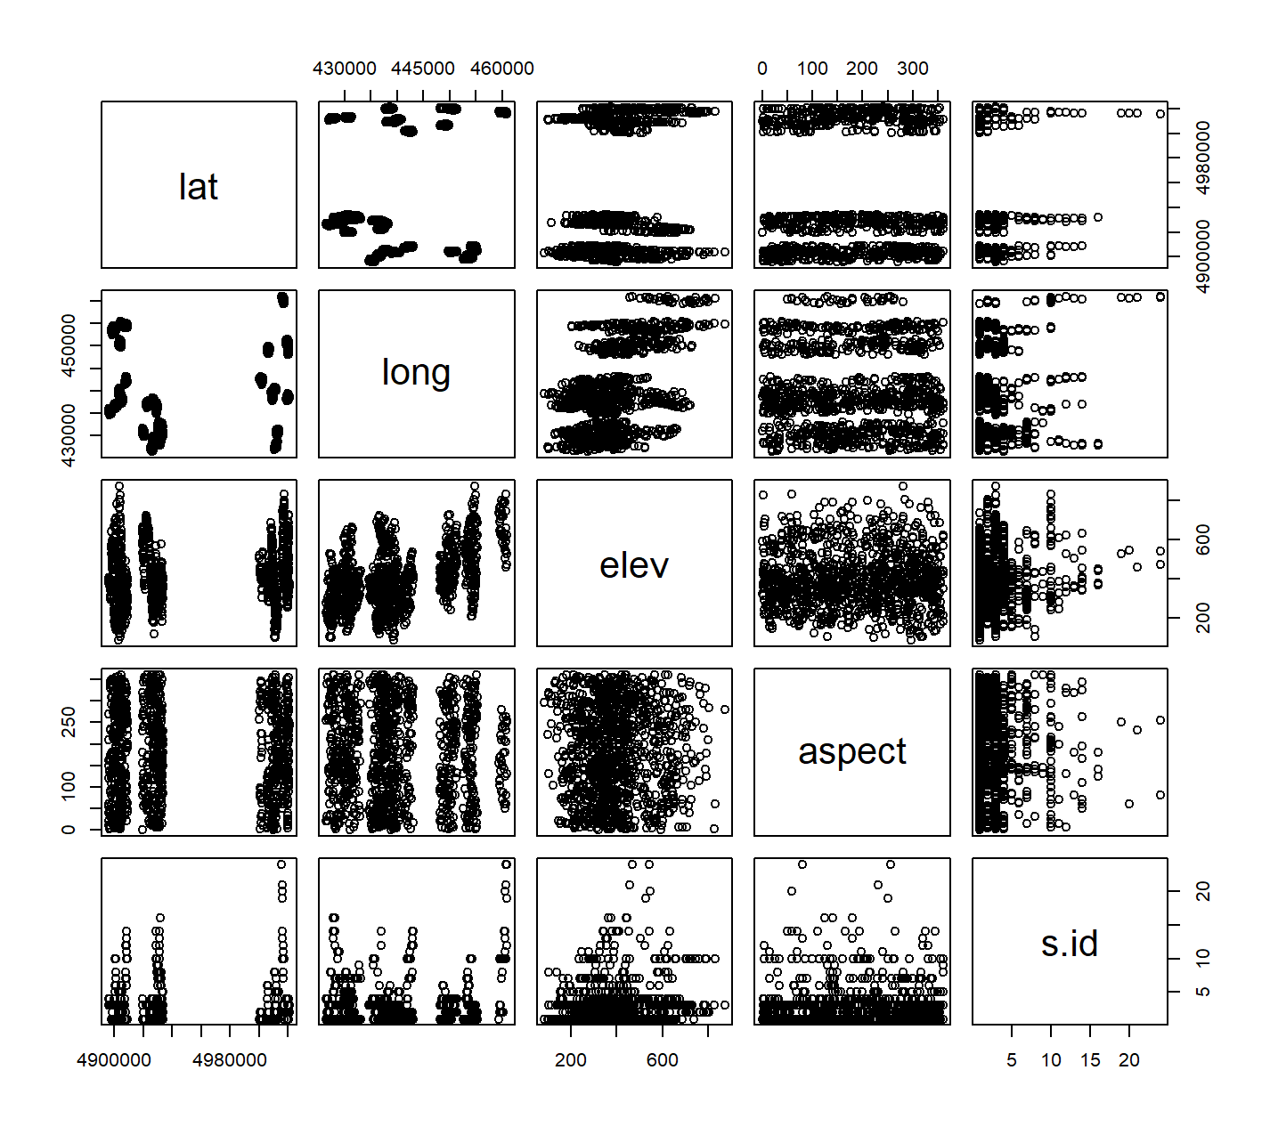
2. The distribution was skewed for this data toward 0. There was almost a complete of absence of Ruffed Grouse (RUGR) except for one spotting. Almost all of the sites had zero observations.
   1. hist(dat_bird$RUGR, xlab = "Number of birds", breaks = 0:7 - 0.5)

